CONTROL AND EXPERIMENT OF AC/AC SPARSE MODULAR MULTILEVEL CONVERTER
ABSTRACT
The sparse modular multilevel converter (MMC) is a new type of high-voltage ac/ac MMC topology suitable for highpower applications. It is based on an alternative configuration of half/full-bridge submodules, and voltage unfolder stages on each side of the converter. This topology has fewer components compared to conventional approaches and as an additional benefit, more than half of the switches operate under the soft switching condition. A comprehensive control strategy is proposed to ensure capacitor voltage balancing while exploiting the full power capability of the converter. A modified unfolder is also suggested to eliminate the inherent zero-crossing circulating current. The effectiveness of the proposed control strategy is confirmed by simulation and experimental results.

BLOCK DIAGRAM FOR PROPOSED SYSTEM
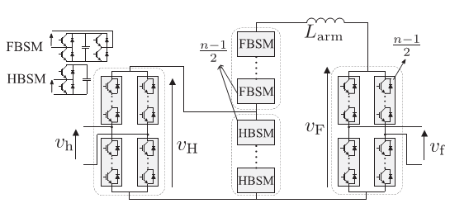
Fig. 1. Schematic diagram of a single-phase n-level SMMC.
DESIGNG SOFTWARE AND TOOLS:
MAT LAB /SIMULATION Software and simu power systems tools are used. Mainly control system tools, power electronics and electrical elements tools are used.

